1) Write a custom tag class HelloWorldTag which displays Helloworld

using msg custom tag in tag handler file and use msg tag in index.jsp

file.

Custom.tld

<taglib>

<tlib-version>1.0</tlib-version>

<jsp-version>2.0</jsp-version>

<short-name>Example TLD</short-name>

<tag>

<name>Hello</name>

<tag-class>com.HelloTag</tag-class>

<body-content>empty</body-content>

</tag>

</taglib>

HelloTag.java

package com;

import javax.servlet.jsp.tagext.*;

import javax.servlet.jsp.*;

import java.io.*;

public class HelloTag extends TagSupport {

public int doStartTag() throws JspException {

JspWriter out = getJspContext().getOut();

try

{

out.println("Hello World");

}

catch(Exception e){}

return SKIP_BODY;

}

}

Index.jsp

<%@ taglib prefix = "ex" uri = "WEB-INF/custom.tld" %>

<ex:Hello/>

Output:-

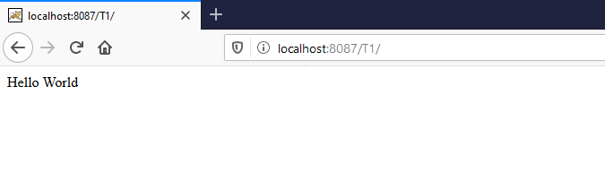

2) Create html form which takes two operands from user and operator

and pass three arguments to jsp page. Based on operator JSP page

perform calculations on numbers. If any arguments is not supplied it

generates error and load Error.jsp page to display appropriate error.

Index.html

<HTML>

<body>

<form action="operate.jsp" method="post">

Enter operator 1:<input type="text" name="no1"><br>

Enter operator 2:<input type="text" name="no2"><br>

Enter operand : <input type="text" name="op"><br>

<input type = "submit" name="sub" value="submit">

</form>

</body>

</HTML>

Operator.jsp

<%@page errorPage="error.jsp"%>

<h2><%

if(request.getParameter("no1")=="" || request.getParameter("no2")=="" || request.getParameter("op")=="")

{

throw new Exception("One or more parameters are missing");

}

int no1 = Integer.parseInt(request.getParameter("no1"));

int no2 = Integer.parseInt(request.getParameter("no2"));

String c=request.getParameter("op");

if(c.equals("+"))

{

out.print(no1+"+"+no2+"="+(no1+no2));

}

if(c.equals("-"))

{

out.print(no1+"-"+no2+"="+(no1-no2));

}

if(c.equals("*"))

{

out.print(no1+"*"+no2+"="+(no1*no2));

}

if(c.equals("/"))

{

out.print(no1+"/"+no2+"="+(no1/no2));

}

%></h2>

Error.jsp

<%@page isErrorPage="true"%>

<%

out.print(exception);

%>

OutPut:-

Without error

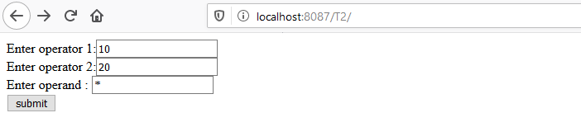

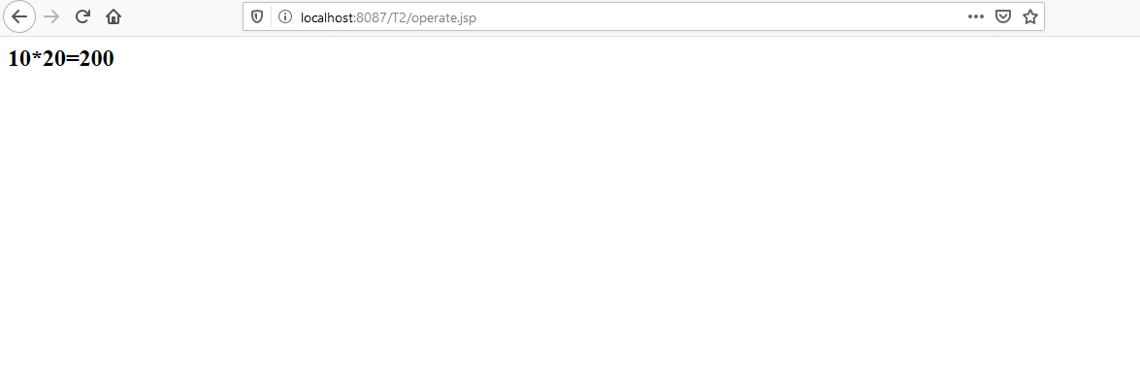

With error

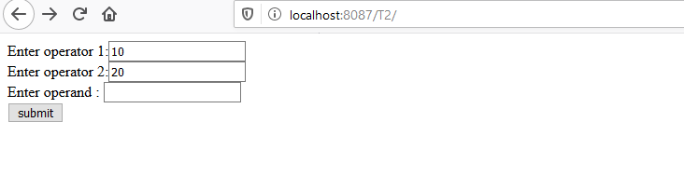

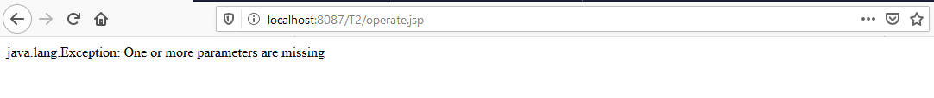

3). Create a jsp application which has custom tag number with attribute and their value. Number tag is processed as odd or even and display result.

TagClass.java

import javax.servlet.jsp.*;

import javax.servlet.jsp.tagext.*;

public class TagClass extends TagSupport

{

int no;

public void setNumber(int no)

{

this.no = no;

}

public int doStartTag() throws JspException

{

JspWriter out = pageContext.getOut();

try

{

if(no%2==0)

{

Out.print(no+”is even”);

}

else

{

Out.print(no+”is odd”);

}

}

catch(Exception e)

{

}

return SKIP_BODY;

}

}

OddEven.tld

<?xml version = “1.0”?>

<taglib>

<tlib-version>1.0</tlib-version>

<jsp-version>2.0</jsp-version>

<tag>

<name>OddEven</name>

<tag-class>com.TagClass</tag-class>

<attribute>

<name>number</name>

<required>true</required>

</attribute>

</tag>

</taglib>

index.jsp

<%@ taglib prefix = "hw" uri = "WEB-INF/OddEven.tld" %>

<h2> <hw:OddEven number=”5”/></h2>

Out put :-

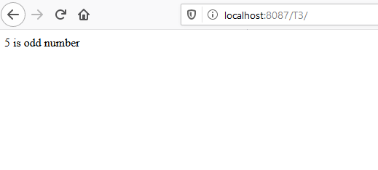

4) Create Employee.html form which takes information like Employee id, name, designation , basic salary. Calculate TA 10% of BASIC, DA 20% of BASIC , HRA 15%of BASIC, MA is 1000 and PF is 4000 for particular employee and result of Gross salary and Net Salary is displayed on JSP page.

<HTML>

<body>

<form action="employee.jsp" method="post">

Employee id:<input type="text" name="id"><br>

Name:<input type="text" name="name"><br>

Designation : <input type="text" name="des"><br>

Baisc Salary : <input type="text" name="bes"><br>

<input type = "submit" name="sub" value="submit">

</form>

</body>

</HTML>

employee.jsp

<%

String id=request.getParameter("id");

String name=request.getParameter("name");

String des=request.getParameter("des");

double bs = Double.parseDouble(request.getParameter("bes"));

double ta = bs * 0.1;

double da = bs * 0.2;

double hra = bs * 0.15;

double ma=1000,pf=4000;

double gs=bs+ta+da+hra+ma;

double ns = gs - pf;

%>

<h4>

Employee id:<%=id %><br>

Employee Name:<%=name %><br>

Employee Designation:<%=des %><br>

Employee Designation:<%=bs %><br>

TA:<%=ta %><br>

DA:<%=da %><br>

HRA:<%=hra %><br>

MA:<%=ma %><br>

Gross Salary:<%=gs %><br>

Net Salary:<%=ns %><br>

</h4>

Out Put:-

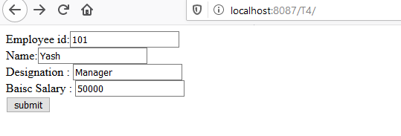

Employee.jsp

